Create Silver Trip_data_green_taxi Pipe:

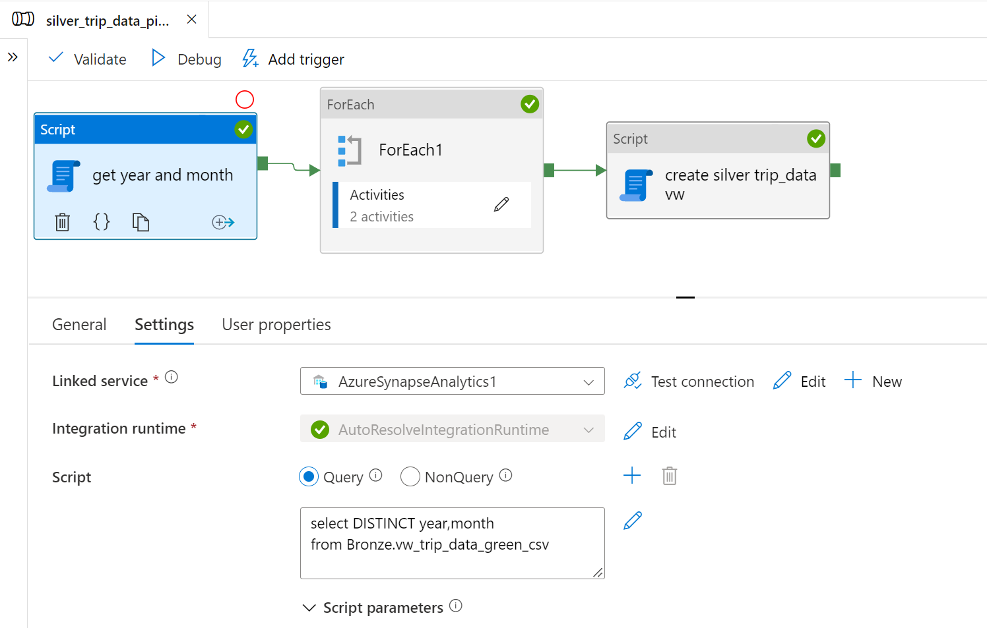

For Each Activity:

Delete Activity Inside For each:

Stored Procedure Activity:

Create silver view trip:

